Press release
New museum reveals the mystery of the mind
‘This museum is about all of us, it’s a collection of 17 million items’
- Hans Looijen, Director of Museum of the Mind
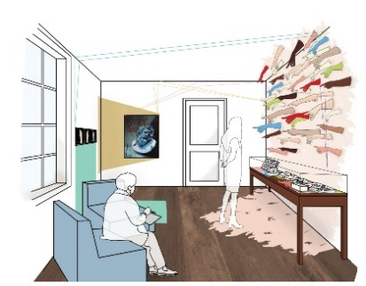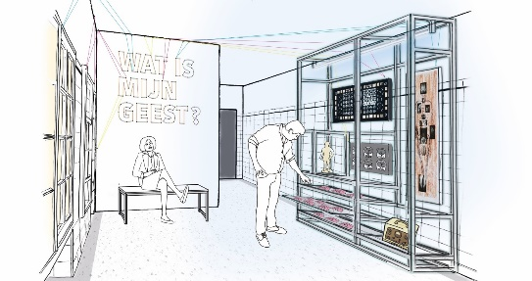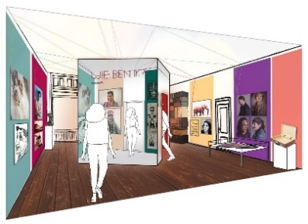
Following extensive renovations, Museum of the Mind | Dolhuys opens this autumn in Haarlem. It’s a museum that invites you on an interactive voyage of discovery into your own mind, and those of others. A museum bursting with personal stories, surprising art and an expansive historical collection, straddling the boundaries between healthcare, art and science. A visit to the museum, located in a centuries-old former leprosarium, plague hospice and madhouse, is an experience focused on the wonder and versatility of the mind. The latest addition to the Dutch museum landscape opens to the public on 25 November.
After arriving through the transparent entrance, designed by Verlaan & Bouwstra architecten, the installation by Studio Nick Verstand sets the mysterious tone. You enter the Resonance Room, a dark space that calms your senses and puts you in touch with your emotions. These very emotions bring the space to life through vibration, audio and projections. Without the need for words, others can experience how you feel. Is this a glimpse of the future? This signals the start of the voyage of discovery into the mind, yet this is not an easy journey to embark on. Because what is the mind? Is it in your body, or elsewhere? Can you influence your mind, and how do you take care of it? The museum uses personal stories, science and life questions to help you discover more about your own mind, and that of other people.
Museum of the Mind introduces you to ideas on this subject through the centuries. Academics, philosophers and artists all try to come to grips with the mind. In addition to classical names such as Aristoteles, Freud and Buddha, modern-day thinkers also share their thoughts, including doctor and researcher Machteld Huber and the Nigerian author of self-help books, Idowu Kayenikan: ‘The mind is just like a muscle - the more you exercise it, the stronger it gets and the more it can expand’.
Visitors also meet various individuals, including rapper and actor Willem de Bruin, who open-heartedly recounts his mental crisis and how music helped him recover. Willem de Bruin: ‘It was like I was in the middle of the ocean, and had to learn how to swim again’. Artists also share their stories. Works on display include Entrance to heaven by Japanese artist Yayoi Kusama, the light installation Fantastic to feel beautiful again by Tracy Emin and Marc Quinn’s compelling Emotional Detox. The first temporary exhibition opens in the restored Care Room, consisting of a single imposing centrepiece: Marlene Dumas’ But who I am is nobody's business.
The original seclusion cell, part of the building itself, remains the historical highlight of the renovated museum. You’ll also see exhibits including a wooden leper clapper, a 19th-century restraint chair, a mental institution jacket embroidered with the Gothic alphabet and Rorschach’s renowned ink blot test. Design agency Kossmanndejong conceived the museum presentation as a combination of contemporary art and the extensive historical collection of more than 700 years of healthcare history.
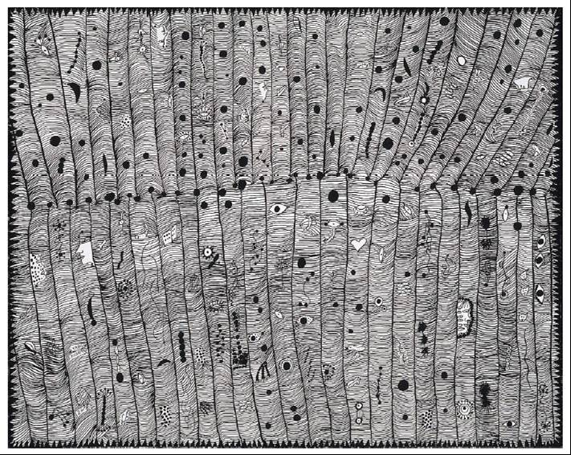 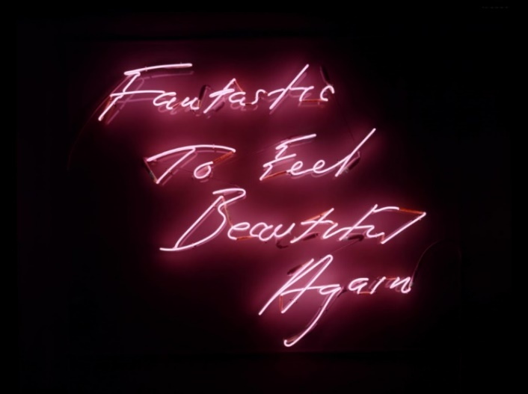
There’s no need for visitors to explore on their own: a multimedia guide developed by media agency IJsfontein gives a voice to the museum’s old walls. They’ll lead the way, ask you critical questions and challenge you. How empathetic are you? And what’s your character like? You’ll also find out more about how you judge, as all of us have the urge to pigeon-hole the human mind. The voyage of discovery into the versatility of the mind ends with a call to sign the ‘universal statement of the open mind’.
Hans Looijen, Director of the Museum of the Mind, is proud of the new concept. ‘The primary theme of our new presentation is mental diversity and psychological health. And this is a theme that is always topical. During the coronavirus crisis, it is vital that you take good care of your mind and remain mentally fit. And it’s essential that everyone joins in, and that we keep an open mind towards each other. If visitors go home after their visit with an open mind and genuine curiosity about others, we have achieved our mission’.
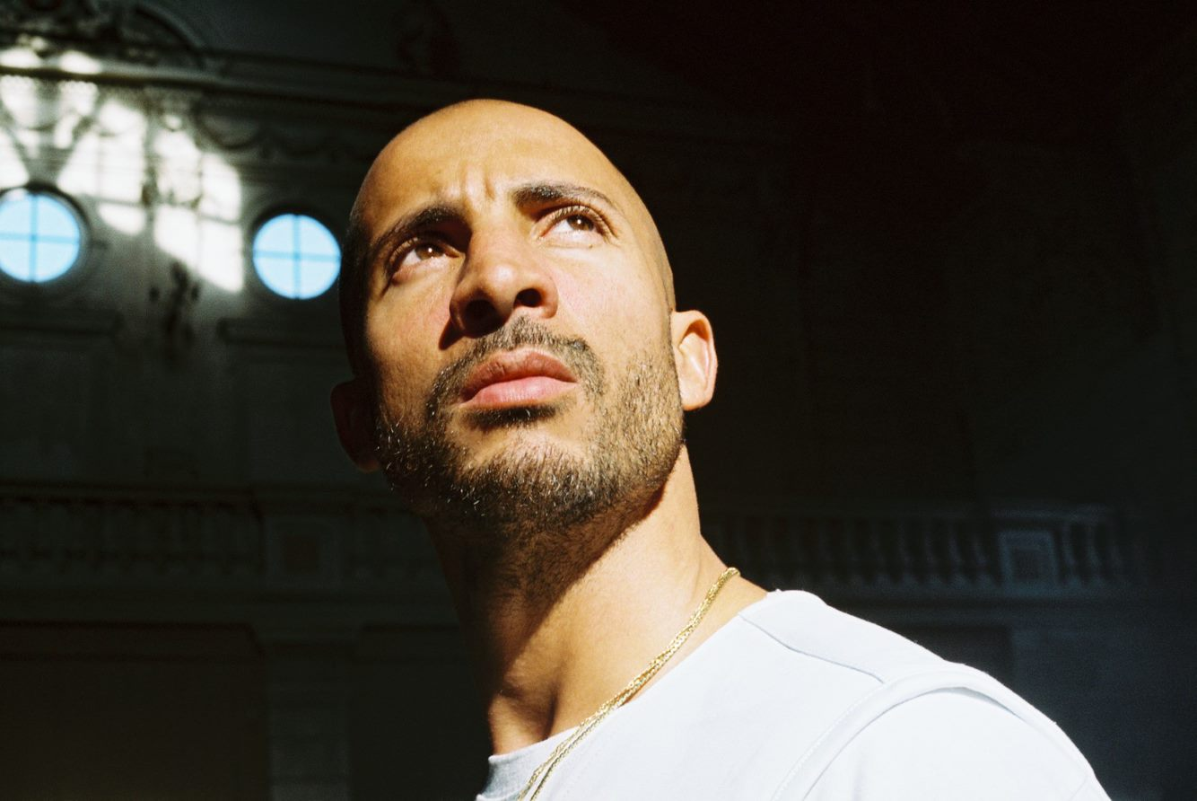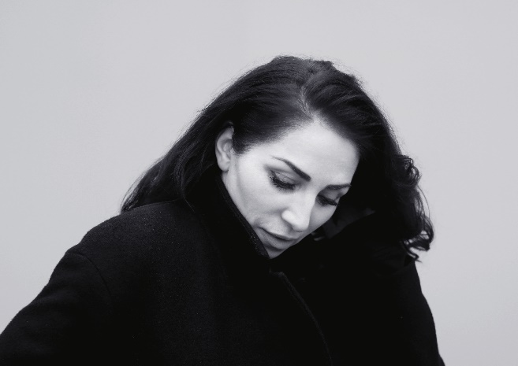
Routes
Visitors can choose from a range of multimedia guides in Dutch and English: expand your horizons with the Open Mind Route, featuring the voice of actor and director Nazmiye Oral. Take your time with the Flow Slow Art Route, developed in collaboration with Flow Magazine. Or make your own guide with the Children’s Route, designed especially for children aged between 8 and 12, and recorded by Willem de Bruin. The Bovenkamer has reopened for secondary school students, offering an educational programme inviting them to explore the pubescent brain. All routes are ‘coronavirus-proof’, with appropriate measures, a clear route and 1.5-metre markings.
Hospitality and venue hire
The museum café ‘Thuys, inspired by Ron Blaauw’ is located in the oldest part of the building, the chapel. Returning the chapel to its original state has transformed the café. In order to bring this element of the museum into line with our mission, we have entered into a partnership with the Ron Blaauw College. The museum will collaborate with chef Ron Blaauw’s team to build the café into a social enterprise offering reintegration employment for those distanced from the job market. The renovated Park Room can host lectures, theatre productions, workshops and debates, as well as welcome school groups. Venues are also available for hire for various occasions, ranging from corporate events to weddings and other celebrations. It goes without saying that we offer suitable 1.5-metre solutions for events.
Renovation and new construction
For the past 18 months, the Dolhuys in Haarlem was completely in scaffolding. The monumental building, owned by the City of Haarlem, required extensive maintenance. A brand-new entrance and welcome area was designed by Verlaan & Bouwstra architecten, to help improve the visitor experience. The architects agency also conceived a new design for the historical chapel. An uninvited guest, the death-watch beetle, was driven off and various old elements were restored or renewed by Lansink B.V. and Verbij Hoogmade (restoration and maintenance) and Bouwbedrijf Burgy (renovation, new construction and installations).
New name
In addition to the renovations, the museum also changed its name. The two museums operated by the Dolhuys Foundation have been united under a single name: Museum of the Mind. In order to specify the location, we refer to Museum of the Mind | Dolhuys in Haarlem and Museum of the Mind | Outsider Art in the Hermitage on the Amstel in Amsterdam. The Amsterdam location hosts exhibitions of outsider art in which artists reveal their inner world.
Founding Fathers
The Museum of the Mind is privately financed and does not receive governmental subsidy. The museum is supported financially by various partners and sponsors, primarily by the Founding Fathers who launched the museum in 2002. These Founding Fathers are four psychiatric institutions: GGZ inGeest, GGZ Noord-Holland-Noord, Arkin and the Parnassia Groep. Despite the Covid-19 crisis, independent funding was successfully raised for the new museum presentation. For the development of the museum programme, we were supported by partners from the mentally disabled care and mental healthcare sectors. The museum will soon launch a crowdfunding campaign to invite the public to make a personal contribution to the mind. The City of Haarlem assumed responsibility for the building and financially supported the renovations.
Collaboration
The content of the redesigned museum was developed in collaboration with various partners, including; the Freud Museum London, De Hersenstichting, Samen Sterk Zonder Stigma, NeuroLabNL, MIND, the Institute for Positive Health, DoorLotjeGetikt, ’s Heeren Loo Zorggroep, SEIN and the Dutch Foundation for Literature.

Note for editors, not for publication
For more information, please contact: Carine Neefjes, Head of Public Affairs & Education, neefjes@museumvandegeest.nl, +31(0)23-5410670 or +31(0)6-51546601 & Nina Bergh, Projects and Digital Content, bergh@museumvandegeest.nl, +31(0)23-5410670 or +31(0)6-39231809.
Visual material
Visual material may be used accompanied by the credits listed below.

